**Experiment 10**

**AIM**: Implement an application that creates an Alarm Clock

**MainActivity.java**

package com.example.lab10_alarm;

import android.app.AlarmManager;

import android.app.NotificationManager;

import android.app.PendingIntent;

import android.content.Intent;

import android.widget.TimePicker;

import android.widget.Toast;

import android.widget.ToggleButton;

import androidx.appcompat.app.AppCompatActivity;

import java.util.Calendar;

public class MainActivity extends AppCompatActivity {

TimePicker timePicker; PendingIntent pendingIntent; AlarmManager alarmManager;

ToggleButton toggleButton; NotificationManager mNotificationManager; Intent intent;

@Override

protected void onCreate(Bundle savedInstanceState) {

super.onCreate(savedInstanceState);

setContentView(R.layout.activity_main);

timePicker = findViewById(R.id.time_picker);

alarmManager = (AlarmManager) getSystemService(ALARM_SERVICE);

toggleButton = findViewById(R.id.toggle_button);

intent = new Intent(this, AlarmReceiver.class);

pendingIntent = PendingIntent.getBroadcast(MainActivity.this, 0, intent, 0);

alarmManager = (AlarmManager) getSystemService(ALARM_SERVICE);

timePicker.setOnTimeChangedListener(new TimePicker.OnTimeChangedListener() {

@Override

public void onTimeChanged(TimePicker view, int hourOfDay, int minute) { toggleButton.setChecked(false); }

});

toggleButton.setOnCheckedChangeListener(new CompoundButton.OnCheckedChangeListener() {

@Override

public void onCheckedChanged(CompoundButton compoundButton, boolean isChecked) {

String toastMessage;

long time;

if (isChecked) {

Calendar calendar = Calendar.getInstance();

calendar.set(Calendar.HOUR_OF_DAY, timePicker.getCurrentHour());

calendar.set(Calendar.MINUTE, timePicker.getCurrentMinute());

time=(calendar.getTimeInMillis()-(calendar.getTimeInMillis()%60000));

if(System.currentTimeMillis()>time) {

if (calendar.AM_PM == 0) { time = time + (1000*60*60*12); }

else { time = time + (1000*60*60*24); }

}

alarmManager.setRepeating(AlarmManager.RTC_WAKEUP, time, 10000, pendingIntent);

toastMessage = "Alarm On!";

} else {

alarmManager.cancel(pendingIntent);

toastMessage = "Alarm Off!";

}

Toast.makeText(MainActivity.this, toastMessage, Toast.LENGTH_SHORT).show();

}

});

mNotificationManager = (NotificationManager) getSystemService(NOTIFICATION_SERVICE);

}

}

**activity_main.xml**

<?xml version="1.0" encoding="utf-8"?>

<LinearLayout xmlns:android="http://schemas.android.com/apk/res/android" android:layout_width="match_parent" android:layout_height="match_parent" android:orientation="vertical">

<TimePicker android:id="@+id/time_picker" android:timePickerMode="clock" android:layout_width="wrap_content" android:layout_height="0dp" android:layout_weight="1"/>

<ToggleButton android:id="@+id/toggle_button" android:padding="20dp" android:textSize="48sp" android:layout_width="match_parent" android:layout_height="wrap_content" />

</LinearLayout>

**AlarmReceiver.java**

package com.example.lab10_alarm;

import android.app.NotificationManager;

import android.app.PendingIntent;

import android.content.BroadcastReceiver;

import android.content.Context;

import android.content.Intent;

import android.net.Uri;

import androidx.core.app.NotificationCompat;

public class AlarmReceiver extends BroadcastReceiver {

private NotificationManager mNotificationManager;

@Override

public void onReceive(Context context, Intent intent) {

mNotificationManager = (NotificationManager) context.getSystemService(Context.NOTIFICATION_SERVICE);

Uri alarmUri = RingtoneManager.getDefaultUri(RingtoneManager.TYPE_ALARM);

if (alarmUri == null) { alarmUri = RingtoneManager.getDefaultUri(RingtoneManager.TYPE_NOTIFICATION); }

Ringtone ringtone = RingtoneManager.getRingtone(context, alarmUri);

ringtone.play();

deliverNotification(context);

}

private void deliverNotification(Context context) {

Intent contentIntent = new Intent(context, MainActivity.class);

PendingIntent contentPendingIntent = PendingIntent.getActivity (context, 0, contentIntent, PendingIntent.FLAG_UPDATE_CURRENT);

NotificationCompat.Builder builder = new NotificationCompat.Builder (context, "chaneel_id)

.setSmallIcon(R.drawable.ic_launcher_foreground).setContentTitle("Alarm")

.setContentText("Alarm On! Wake Up!").setContentIntent(contentPendingIntent)

.setPriority(NotificationCompat.PRIORITY_HIGH).setAutoCancel(true);

mNotificationManager.notify(NOTIFICATION_ID, builder.build());

}

}

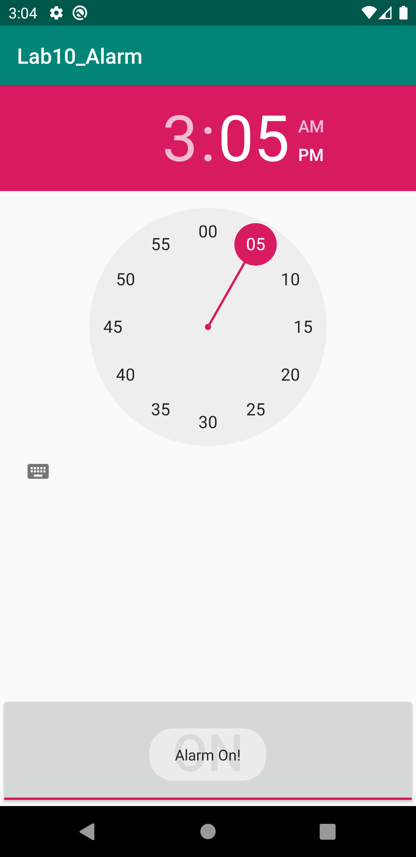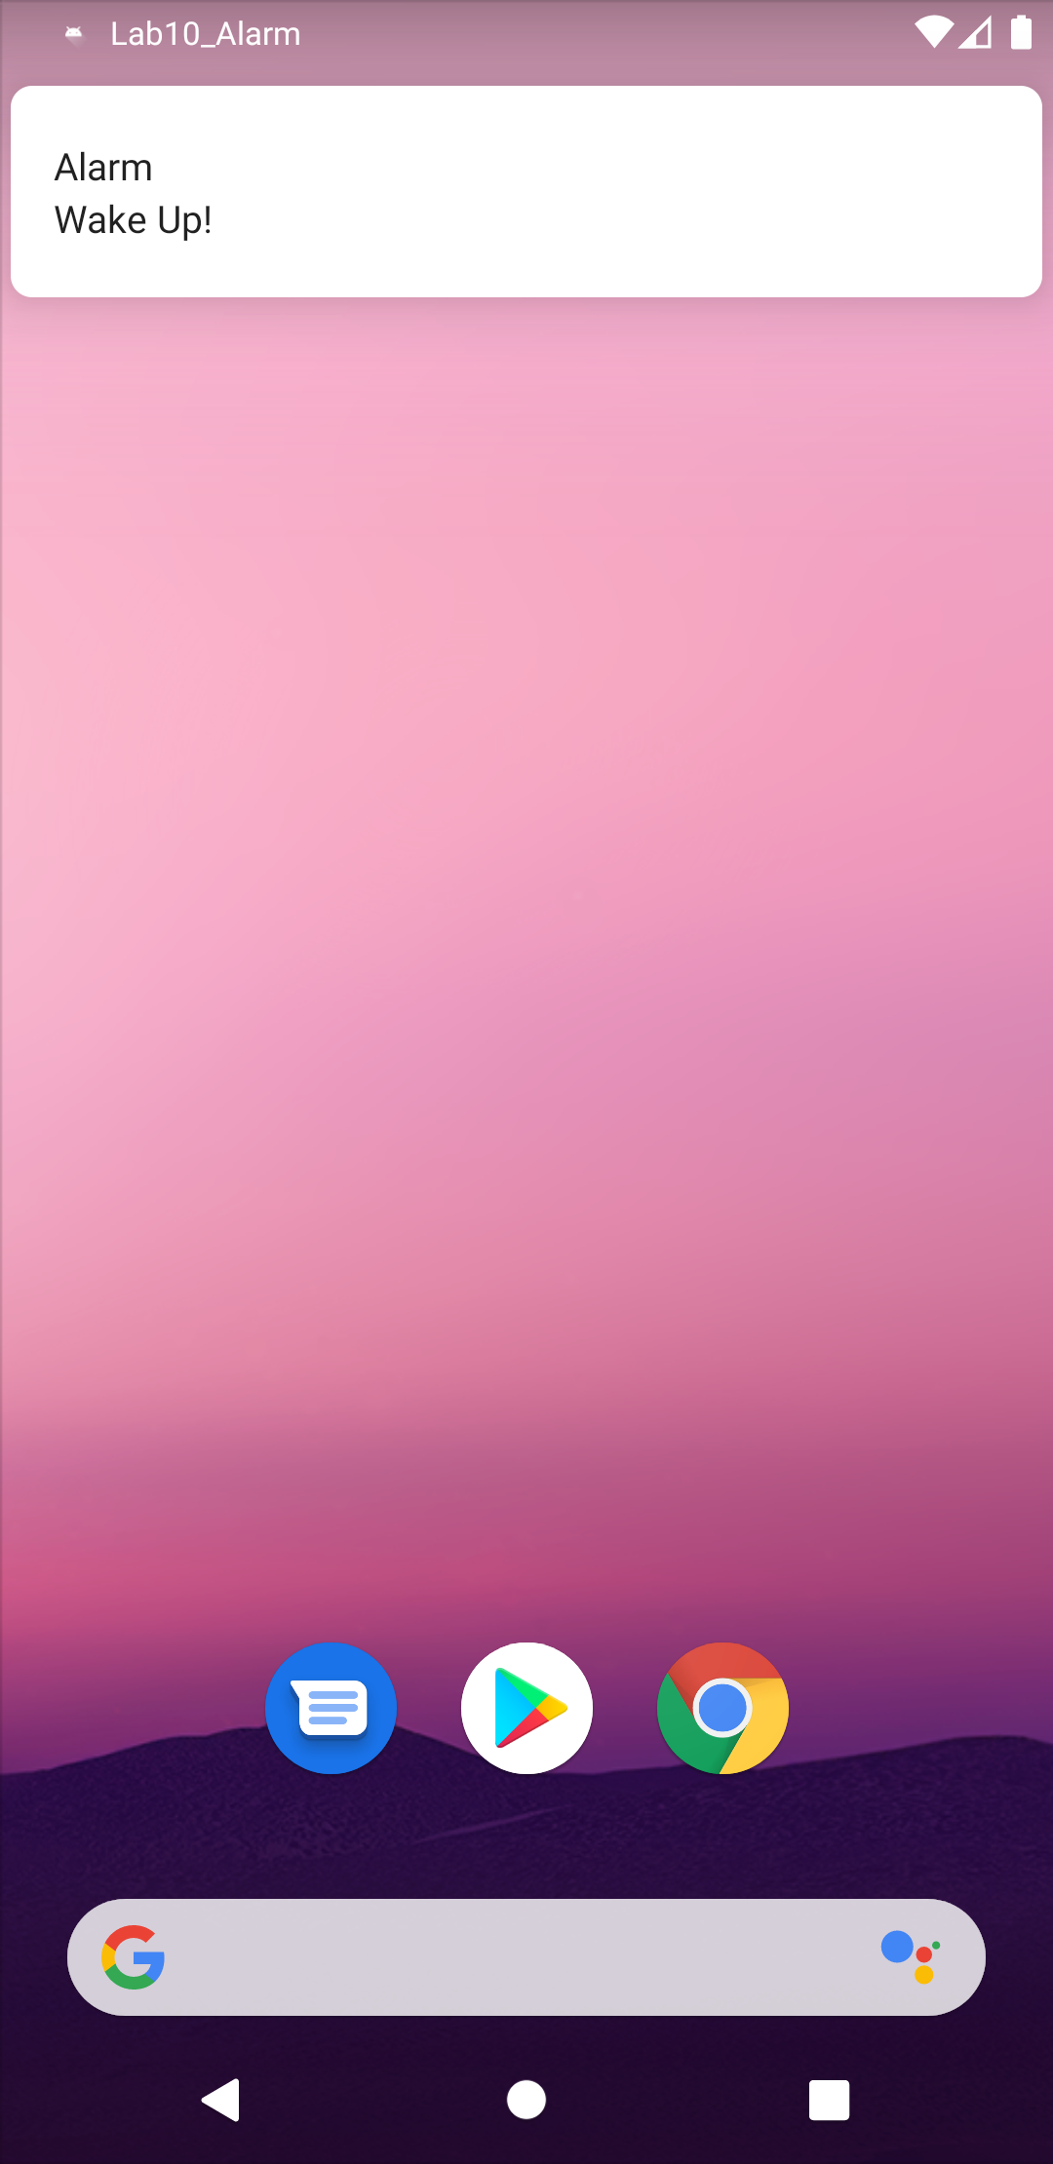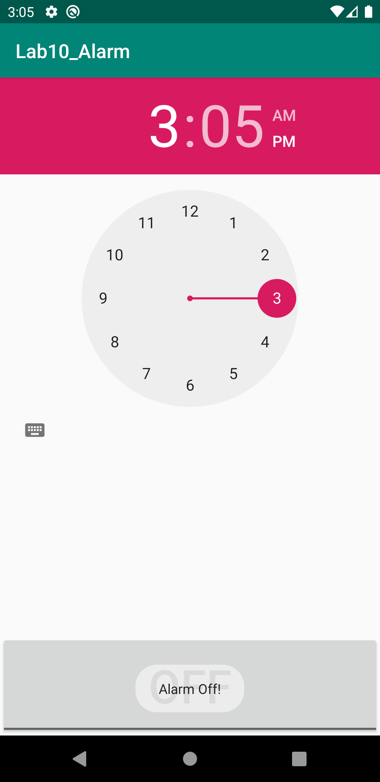**Output**